CREATING SHORTCUT ICON FOR FILE

Step1. Right Click the mouse button.

Step2.New->shortcut.

Step3. After selecting shortcut, we will see create shortcut window

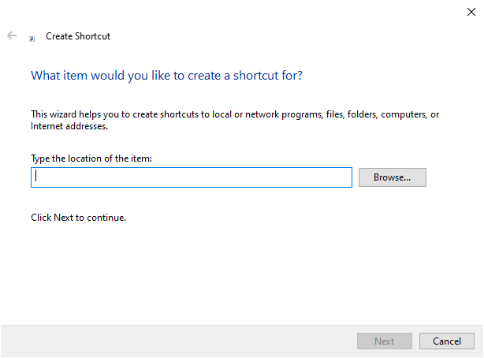

Step4. Enter absolute path of ‘index.html’ in text box. Click the Next button.

Step5. We will see below window.

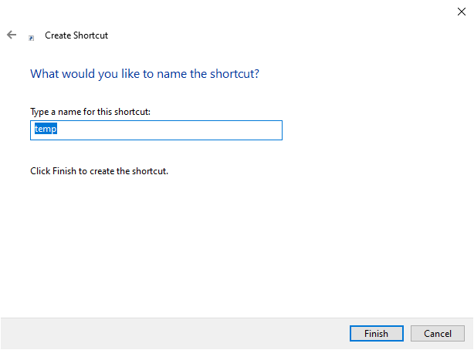

Stpe6. Enter a Name for shortcut and click the finish button.

Now Shortcut icon for ‘Index.html’ file has been created on desktop.

CHANGING IMAGE IN SHORTCUT ICON

Step1. Down load/collect image. It should be a .icon file.

Step2. If image is in .jpeg or other format, then convert into .icon format through online.

<https://www.icoconverter.com/>

step3. Right click on short cut icon on desktop and select ‘properties’ option.

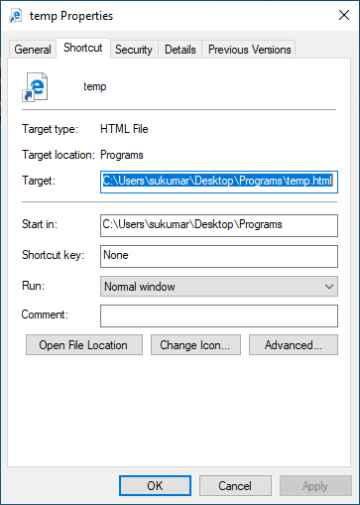

Step4: Enter a short cut key in ‘ Shortcut key’ text box. This is optional.

Step5: click the change icon. After clicking , we will see Change icon window.

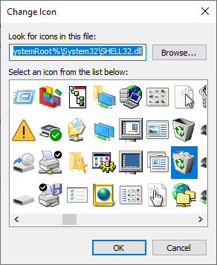

Step6: Select icon from list or browse it. When you click the ok button, Immediately shortcut image will be changed.